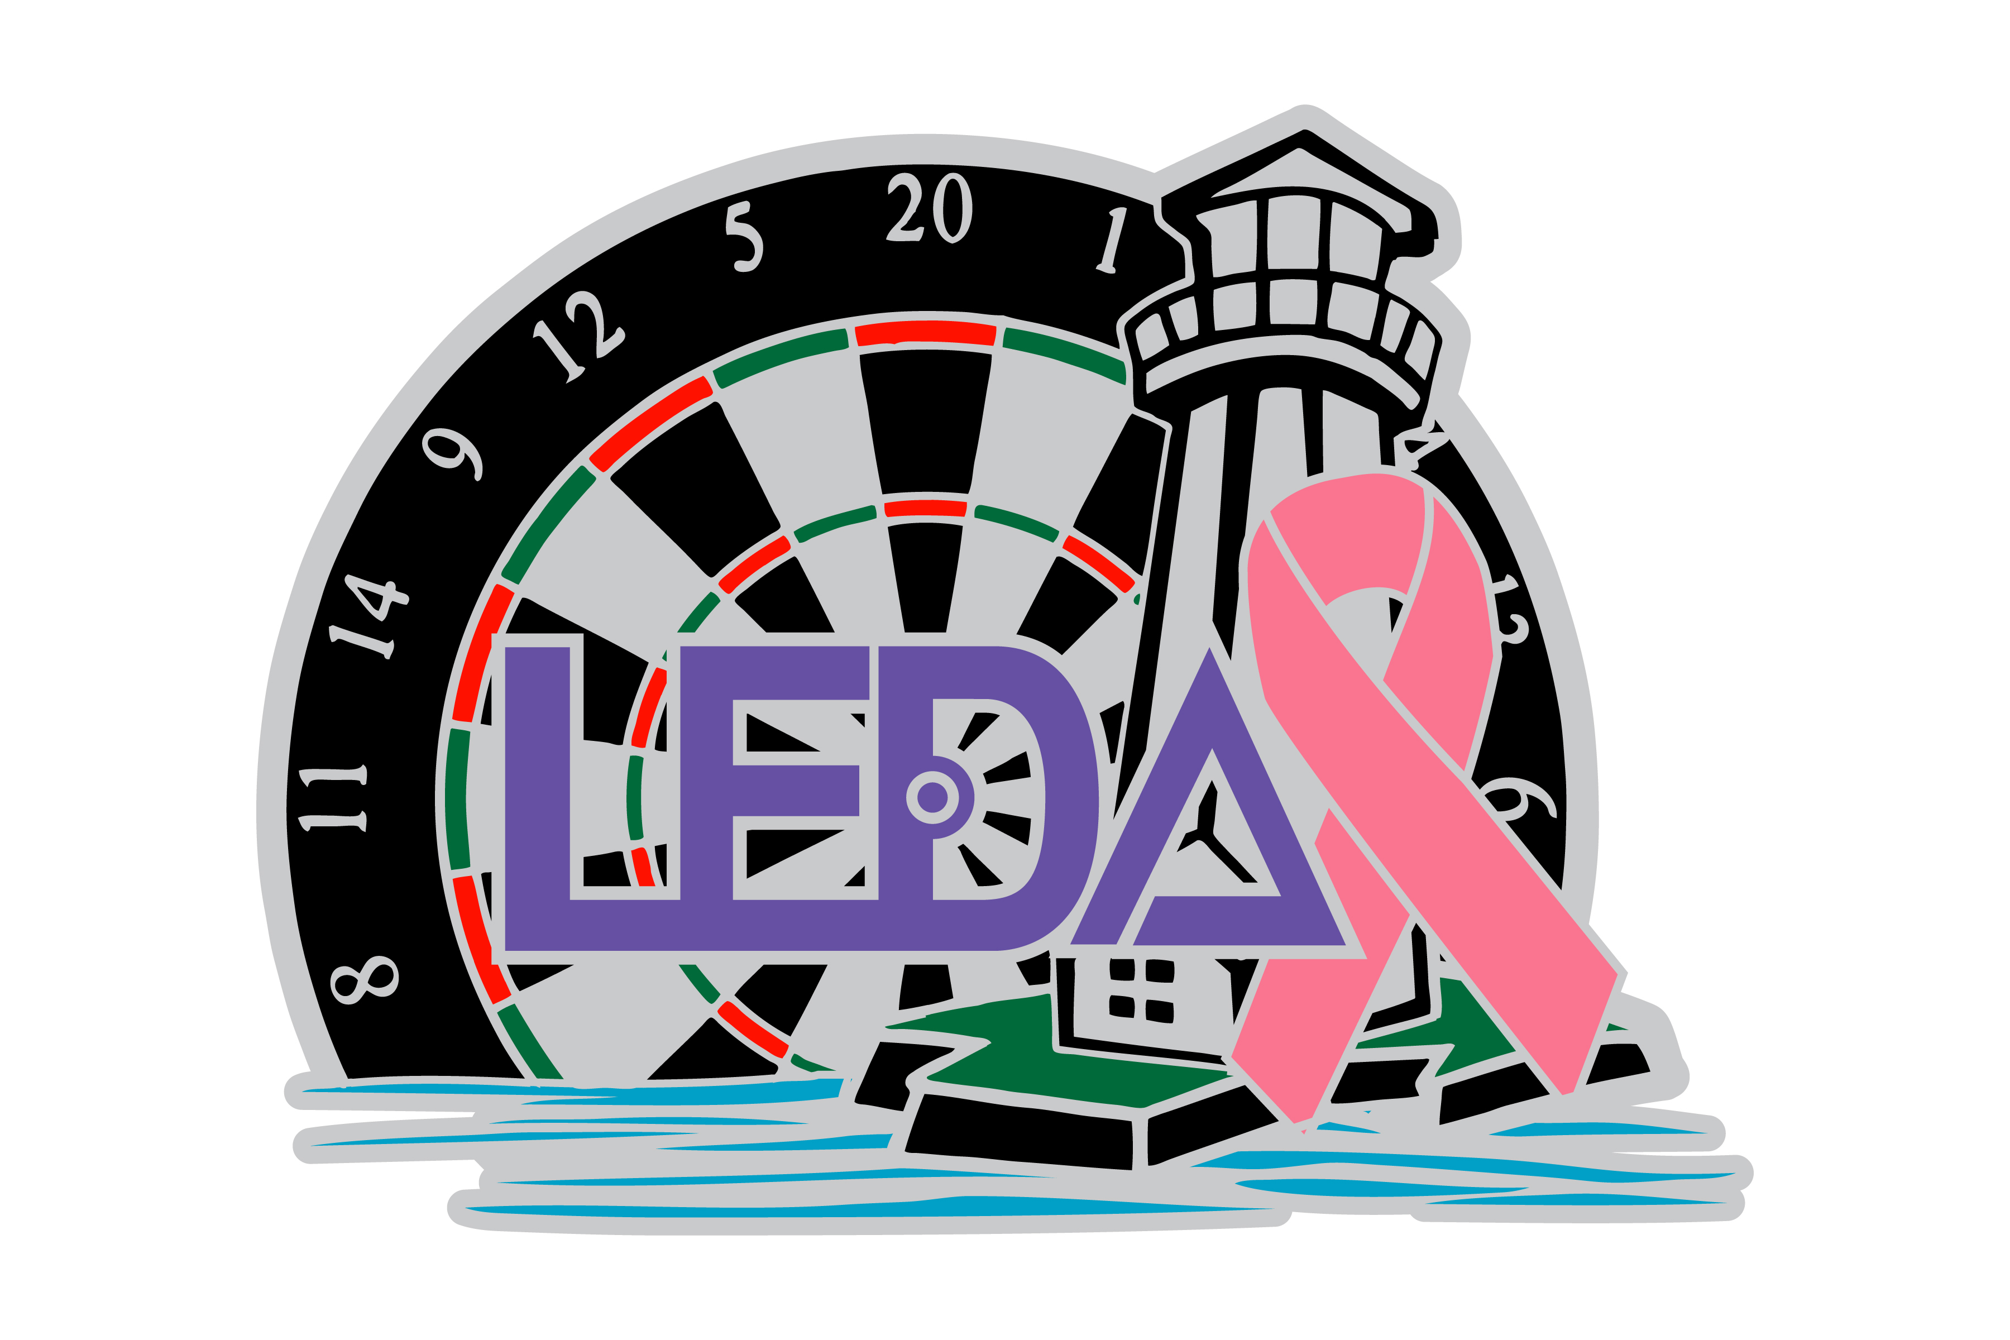
LEDA’S-9th Annual
Cricket for Breast Cancer
Come support a great cause and warm-up for
The ADO Cricket Singles National Qualifier for ADO Region 4-6
Date: Saturday–November 4th, 2017
Tournament Site and Accommodations: Quail Hollow Resort 11080 Concord-Hambden Road, Painesville, Ohio 44077
Phone: 440-497-1100 www.quailhollowresort.com
$82 Darter Rate
EVENTS:
Men’s Singles – 1:00PM – Double Elimination**
Women’s Singles – 3:00PM – Double Elimination**
Mixed Doubles – 5:00PM – Single Elimination**
Blind Draw – 7:00PM or as soon as all other events are finished.
****registration closes 15 minutes prior to events****
$10.00 entry fee per person – per event

Format: Single events - All Cricket, best of 3 – Double Elimination
Losers bracket one game – Finals Best of 3
Blind Draw & Mixed Doubles–All Cricket–Single Elimination 50/50 Split on Payouts
$Money added to Blind Draw by LEDA
**Double elimination subject to change **
Chinese auction and 50/50 drawings
Food and Drink specials all day!!!!!
All funds raised will be donated to Lake Health’s - Breast Health Program
Sunday – November 5th, 2017
ADO Cricket Singles National Championship Qualifier. The cost to compete in a National Qualifier is $110 per person. Players can pay outright or earn their $110 entry fee by participating in a local qualifier. Speak to your ADO Representative for more information on local qualifiers.

The ADO Cricket Singles National Qualifier for ADO Region 4-6 will be held at Quail Hollow Resort & Conference Center,
Start time: 1:00PM – Doors will be open at 11:00AM for warm ups.
The format will be a round robin event, 3 legs of Cricket per round. Depending upon the number of participants will determine number of players advancing to the ADO Cricket Singles National Finals
(1 person per advances per every 8 participants).
Players who advance to the National Finals will be reimbursed for roundtrip transportation plus a $150 stipend from the ADO.

